Phase 5

Lesson 4

**Push an Image to Docker Hub**

This section will guide you to**:**

* Build a custom Docker image and push it to Docker Hub.

Steps:

1. Preparing a custom Docker image

2. Pushing the Docker image to Docker Hub

**Step 1:**

Check is you already have a custom docker image if not create one custom image

To check images:

**Docker images**



**Step 2:**

Sign up to docker hub

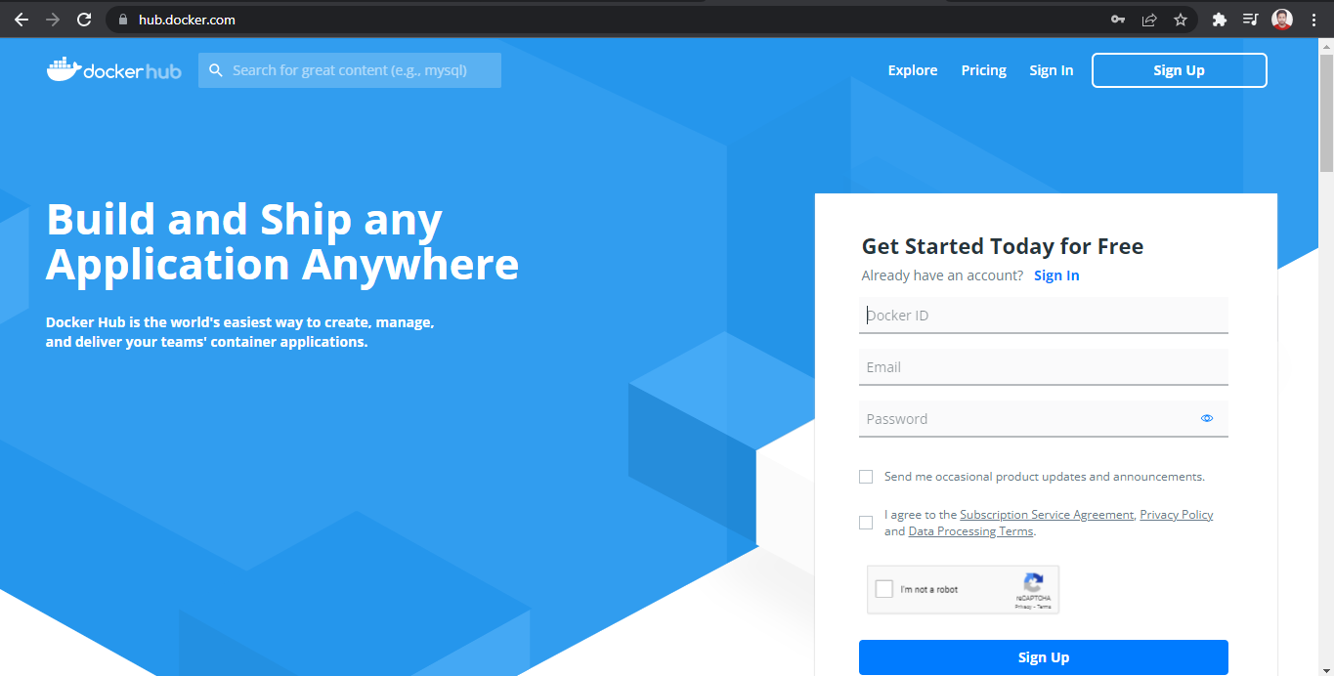

After sign up sign in to the docker hub dashboard.

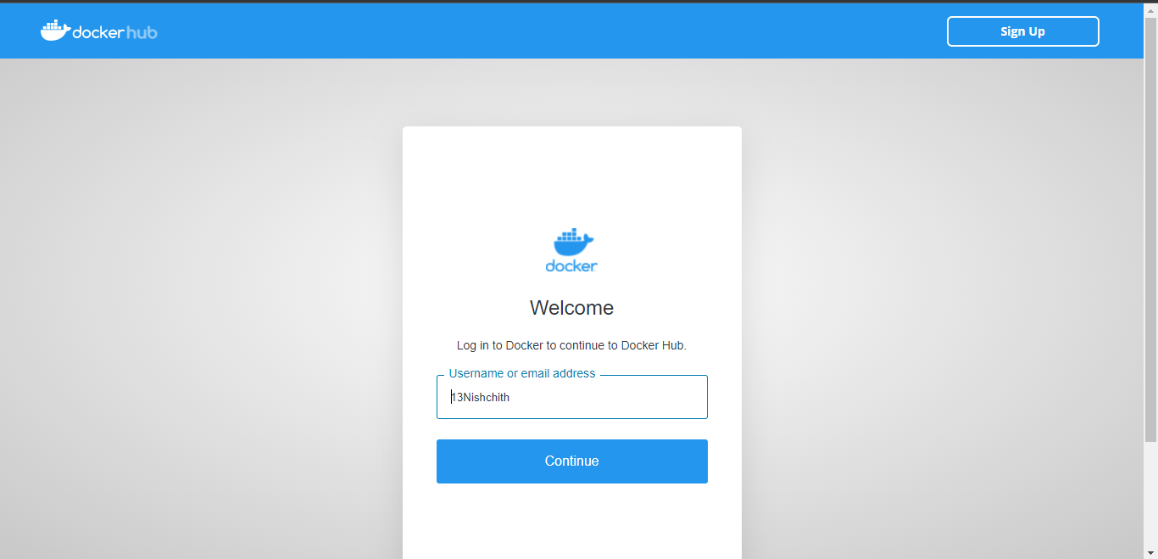

**Step 3:**

Login to docker hub using

**docker login**

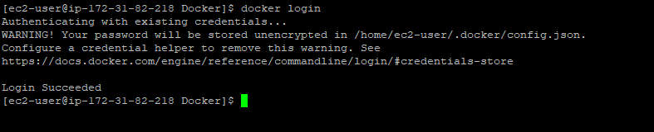

**Step 3:**

Do tag for the existing image.

**docker tag phpcode 13nishchith/php-code**

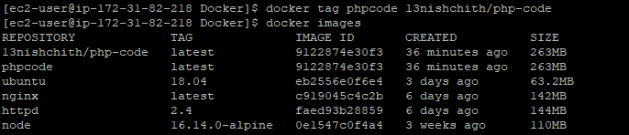

Check the images using **docker images**



After building image using tag command push the image to dockerhub.

**docker push 13nishchith/php-code**

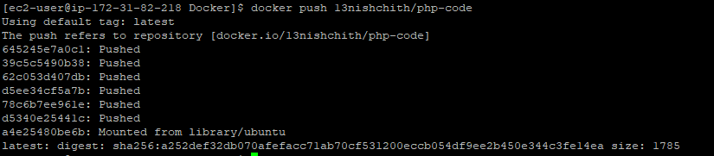

**Step 4:**

Go to the docker hub check for the pushed images.

